**DAY 1**

**Reviewing ACL:**

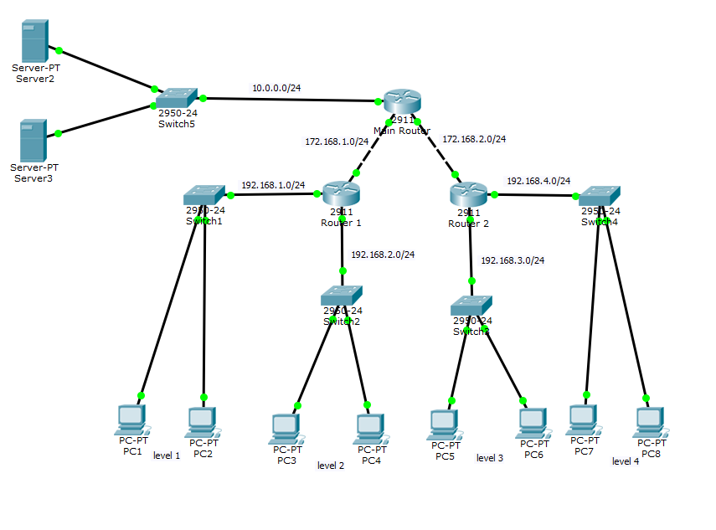

Build the above network.

Rules:

1. Deny level network (192.168.1.0/24) to the server network(10.0.0.0/24)
2. Deny PC1 access to level 4 network (192.168.4.0/24)
3. Deny PC3 access to PC5
4. Deny PC4 access to PC 6
5. Deny level 3 network (192.168.3.0/24) access to “Server3” (10.0.0.11)
6. Deny FTP access to server2(10.0.0.10) for level 2 network(192.168.2.0/24)
7. **Only allow PC5 telnet access to server2(10.0.0.10) in the level 3 network**
8. **Deny level 3 network pinging to server3 (10.0.0.11)**
9. **Only allow level 2 and level 4 network web access to the server network**

**Need to add more rules in this**

**RIP:**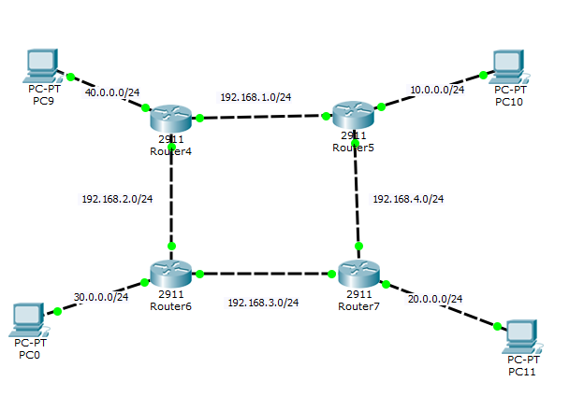

Configure the above network using RIP protocol version 1

**OSPF:**



Configure the above network using OSPF protocol

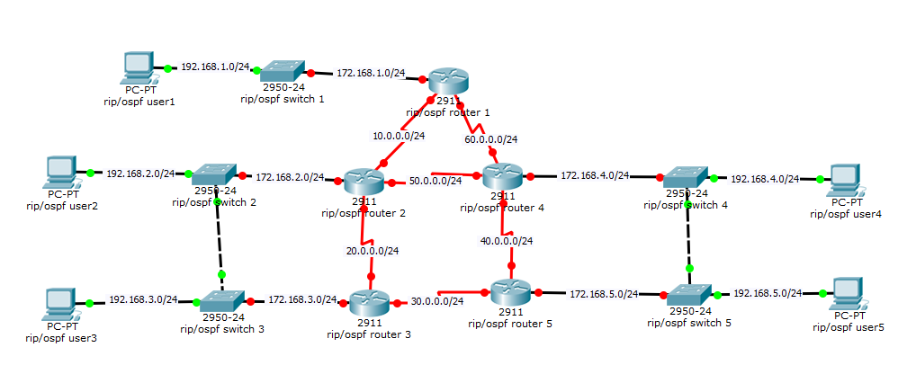

Configure the above network using first RIP and then using OSPF

**EMAIL SERVER:**

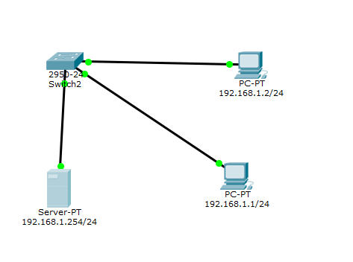

Create a user on both PCs. Verify if both the users can send emails to each other.

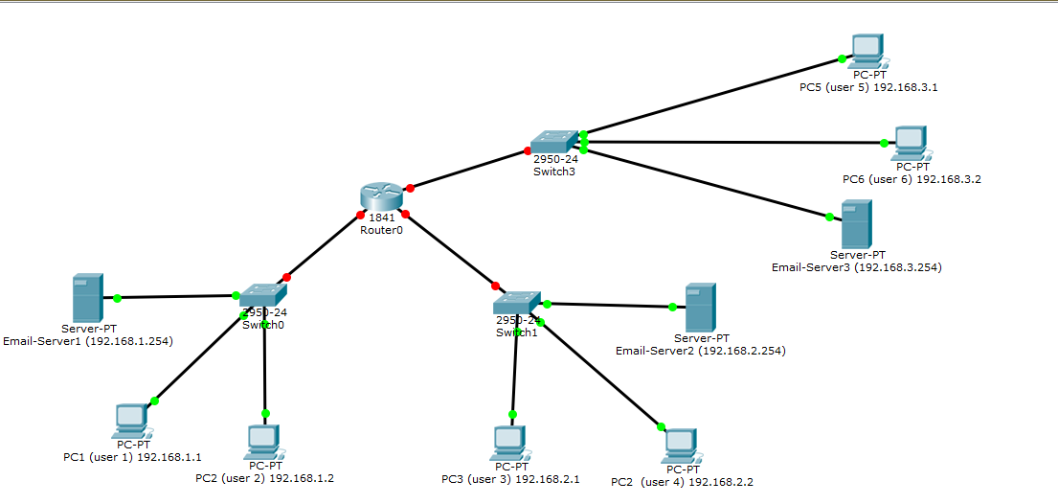

Configure the above network such that Server-PT are the 3 Email-Servers. Configure 6 users as shown above. You can have any domain name of the 3 Email-Server. Verify if all the 6 users can email each other.

Lab created by Rugved Jakka.